**Name- Pranjul Singhal**

**College- GLA University, Mathura**

**Email id- pranjul.singhal_ccv17@gla.ac.in**

ASSIGNMENT 6

Launch one free flavor/machine type with windows server (instance) on GCP/Azure. Configure an IIS server with your Default web page once, then also try to change the Index.html page.

**Steps-**

1. Open Microsoft Azur portal and create a Virtual machine.

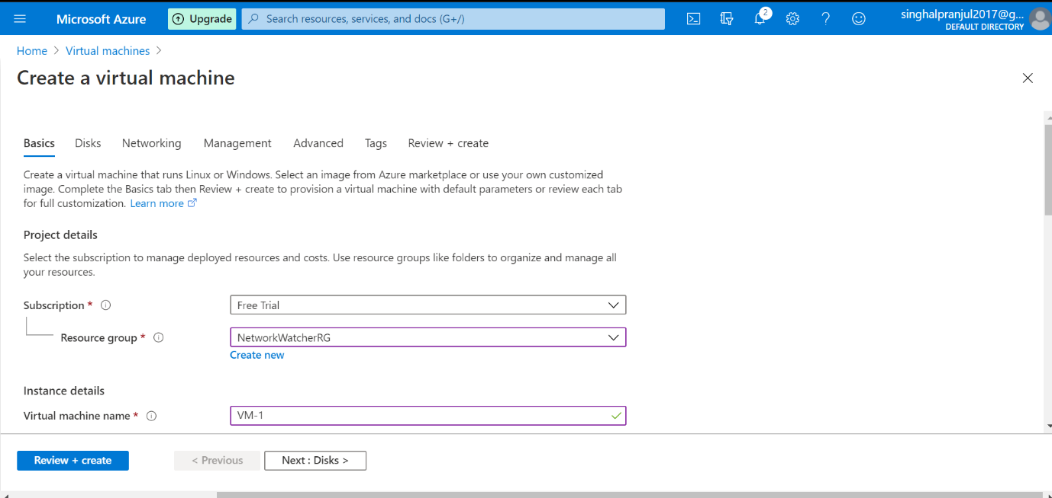

2. Add the disk into VM

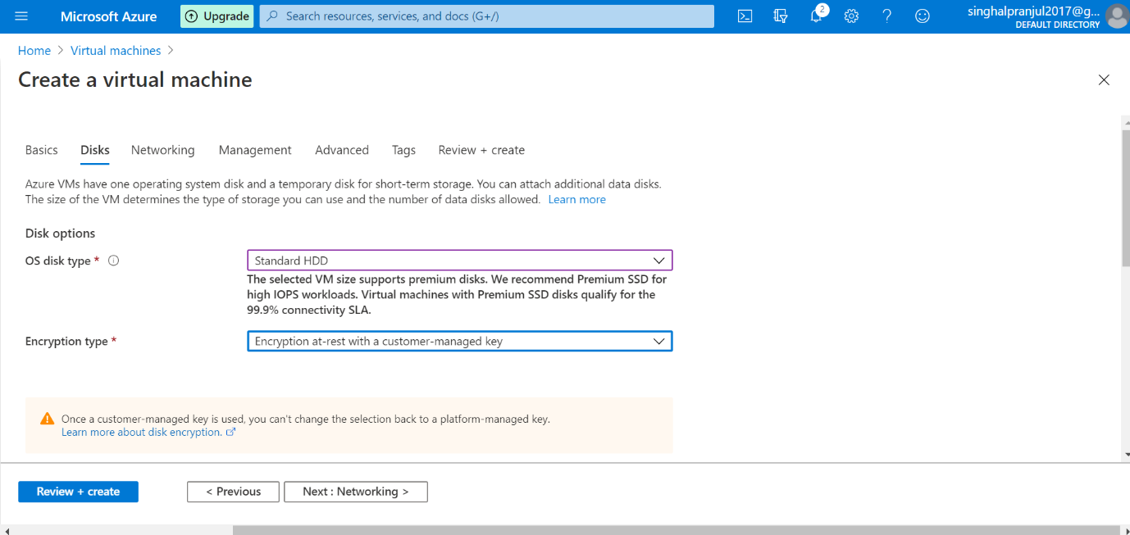

3. Add network to the VM to connect

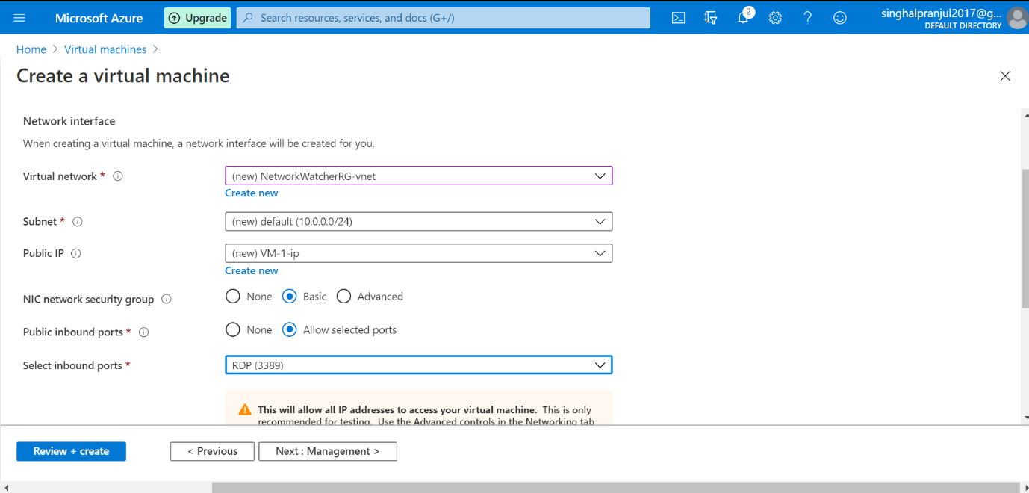

4. Set the management and storage

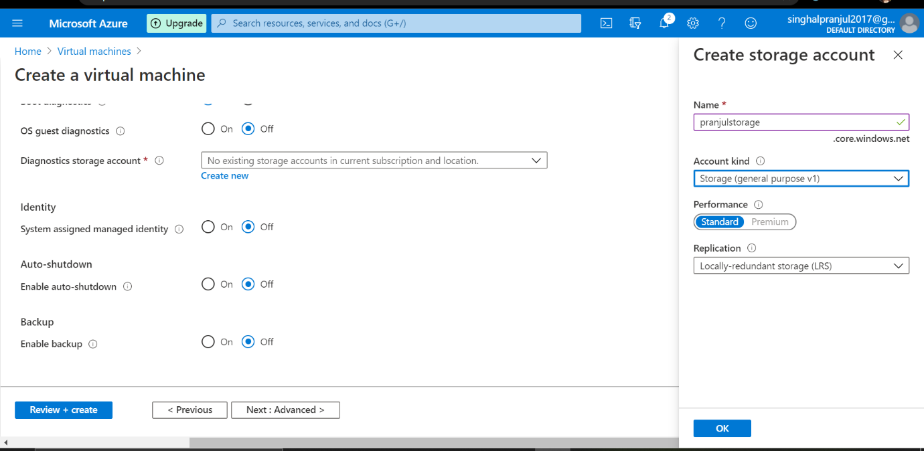

5. Review and create the VM

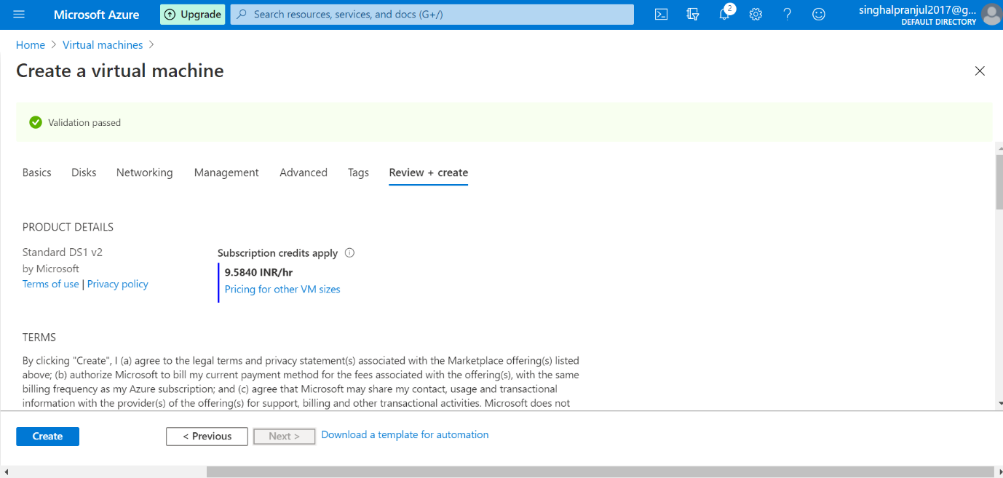

6. The VM will be deployed

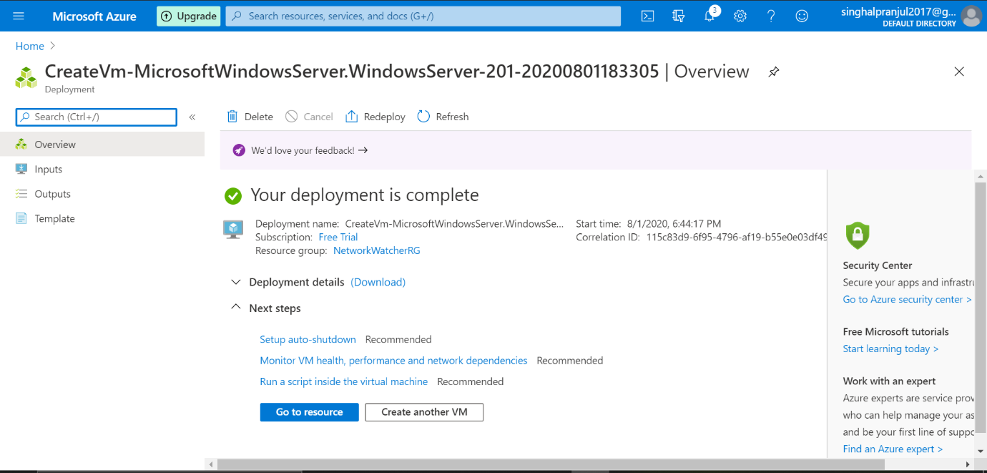

7. Now open ‘remote desktop connection’ on desktop and copy the public ip of the VM on it

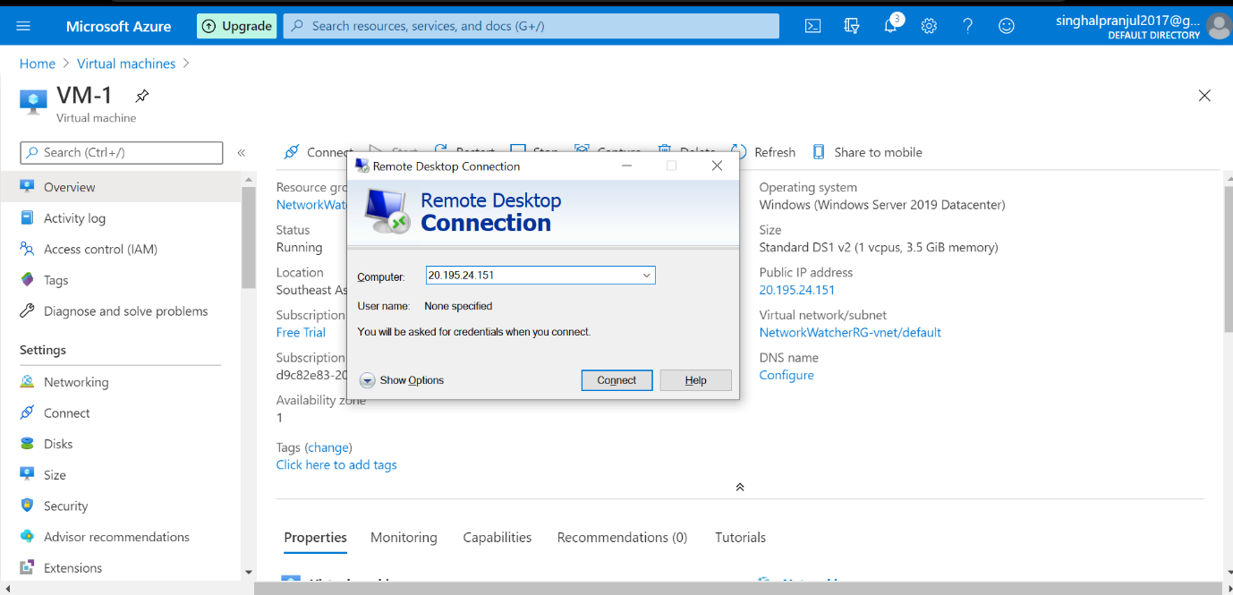

8. The VM will appear on the screen. Click on ‘Add roles and features’.

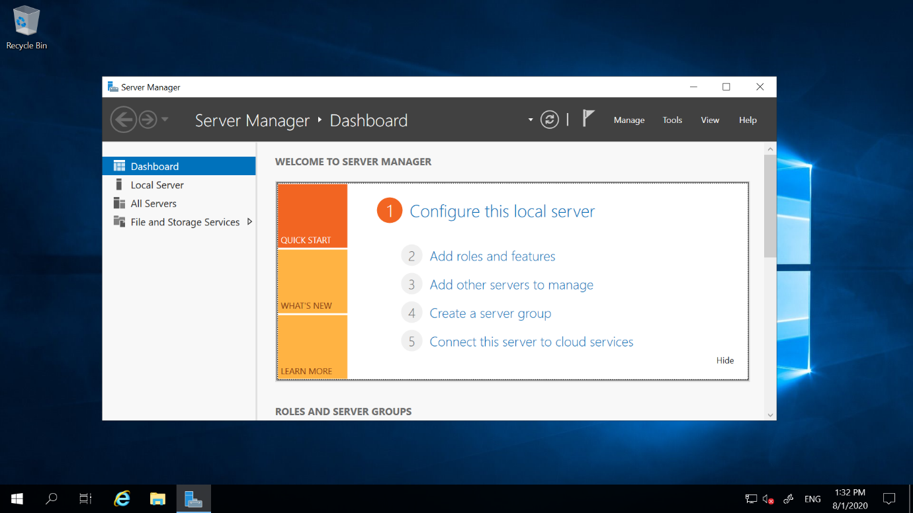

9. Choose the role

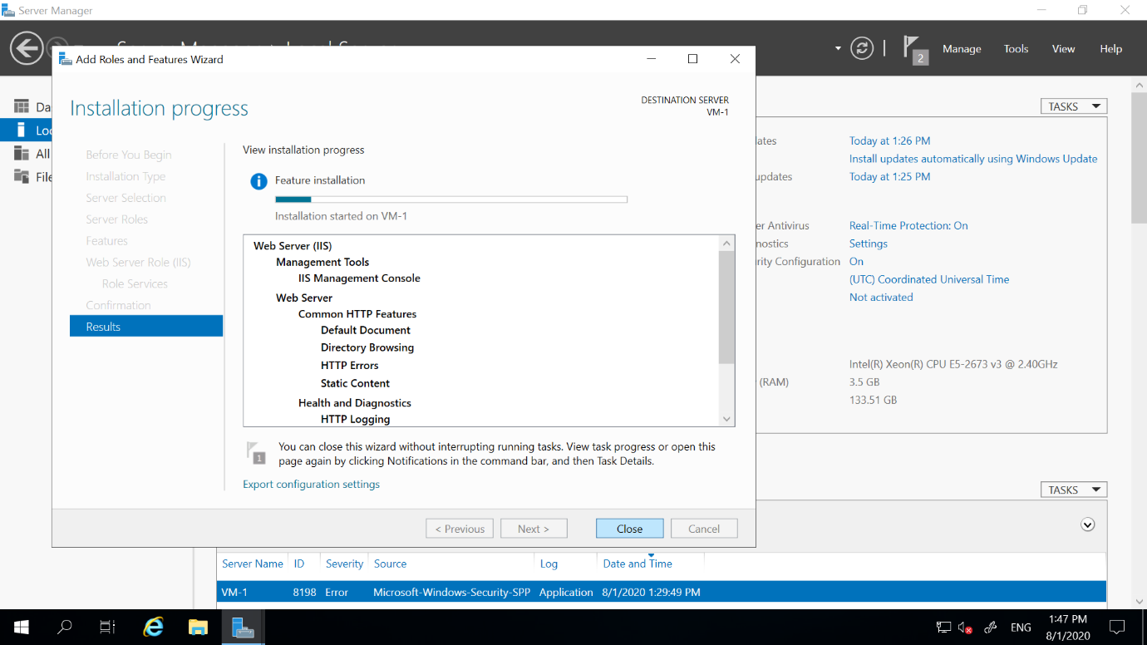

10. Now click on install

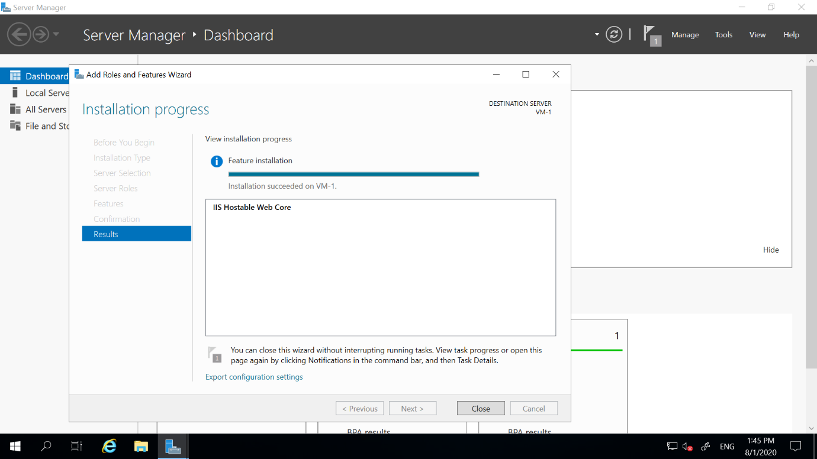

11. Now go on Local server and click on ‘ON’

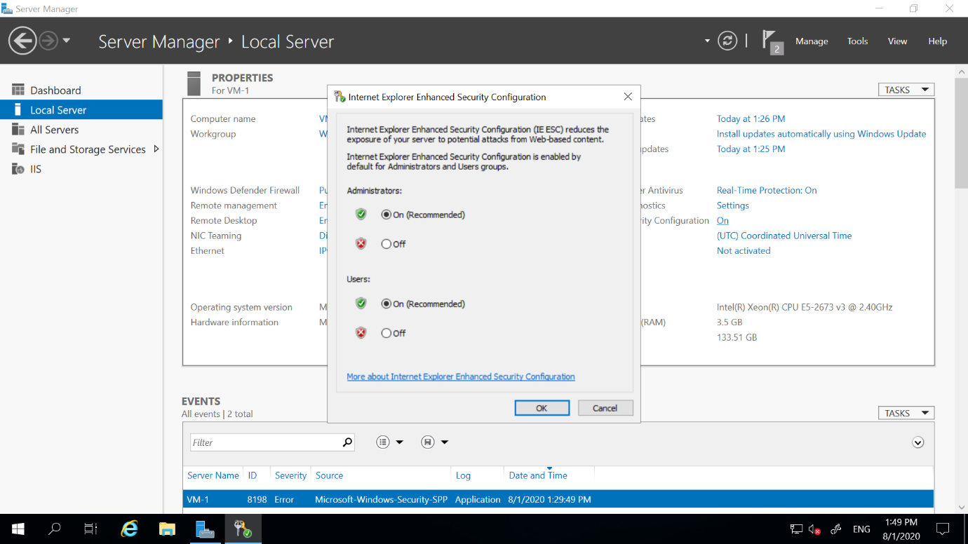

12. Now go to C drive and Open ‘wwwroot’

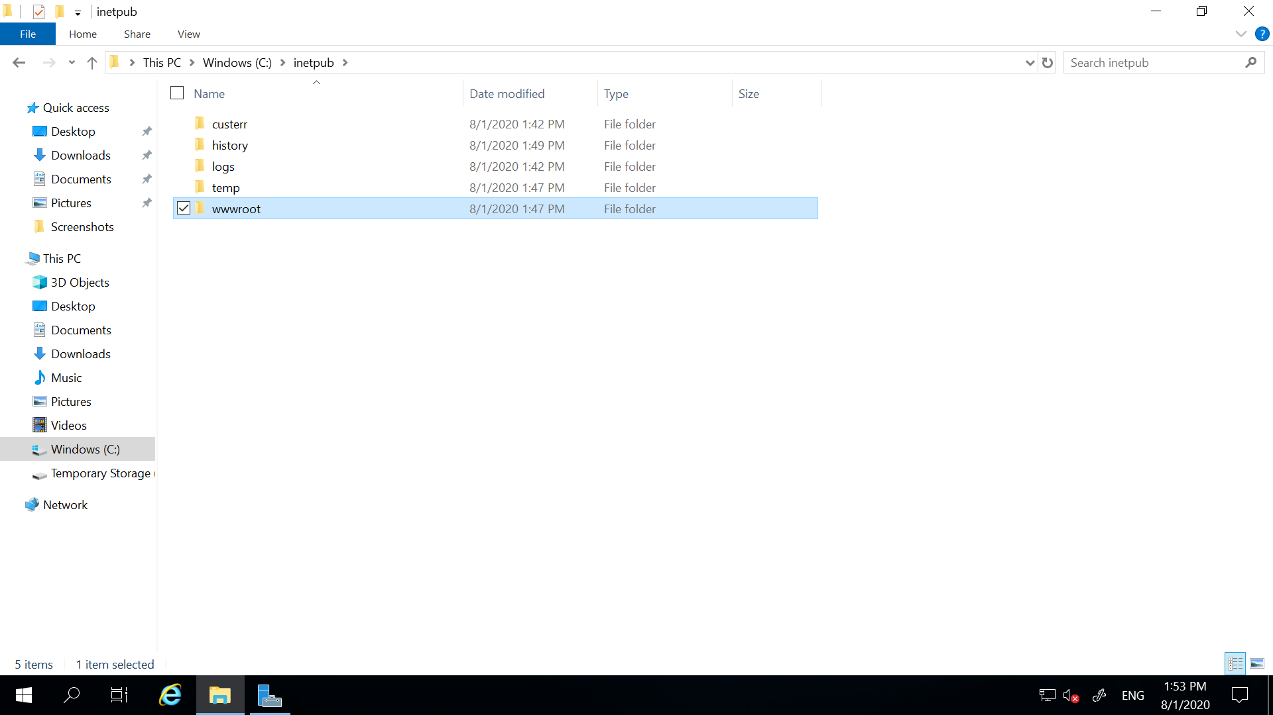

13. Open the html file and the window will appear

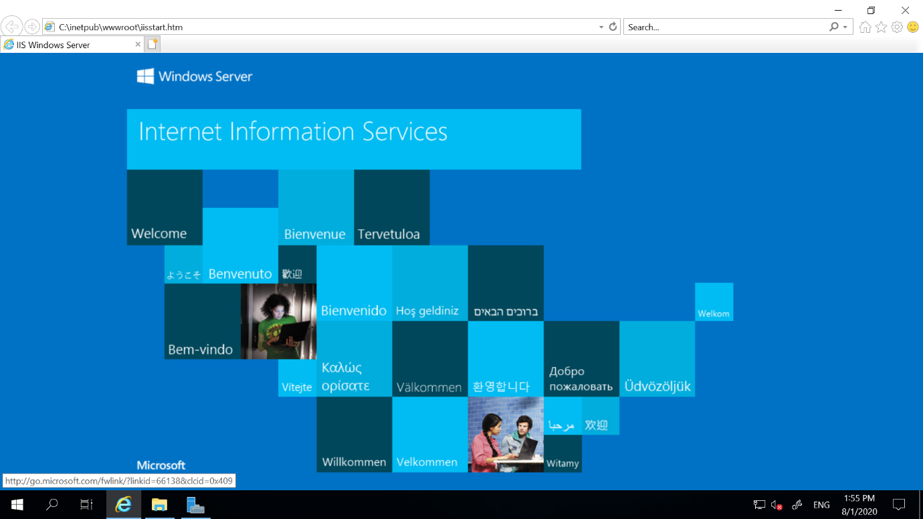

14. Now go to the dashboard and click on tools on right hand side and click on

IIS Manager.

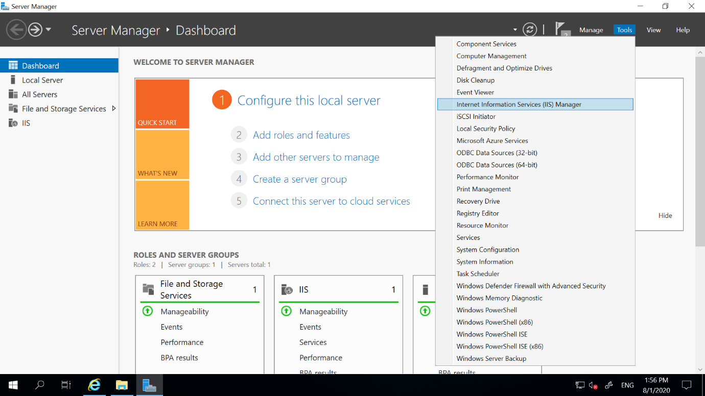

15. Open the default website

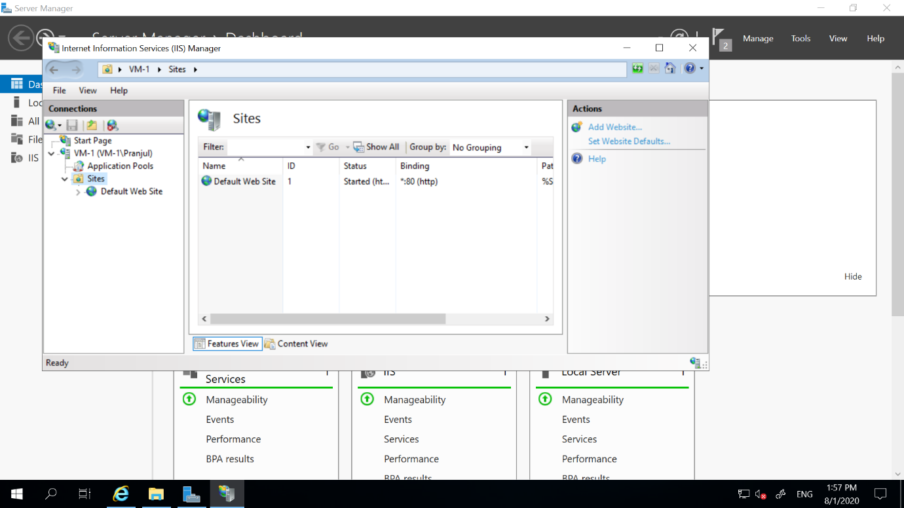

16. And window of IIS will open

